***Ahsanullah University of Science & Technology***

Department of Computer Science & Engineering



Seba-NGO Management System

# Information System Design &

Software Engineering Lab

**CSE-3224**

**Entity Relation Diagram & Class Diagram**

**Quest**

**Submitted By**

# Ashfaq Ali Shafin 14.01.04.111

# Irtiza Abir 14.01.04.122

# Abid Hasan Prottoy 14.01.04.125

## **Introduction:**

## This report has covered two essential parts of this project. These are: **Entity Relation Diagram & Class Diagram**. ERD helped us to determine the data to be stored in the database and the graphical diagrams of ERD made sure of the data flow. On the other hand, Class diagram is not only used for visualizing, describing and documenting different aspects of a system but also for constructing executable code of the software application.

## **Entity Relation Diagram:**

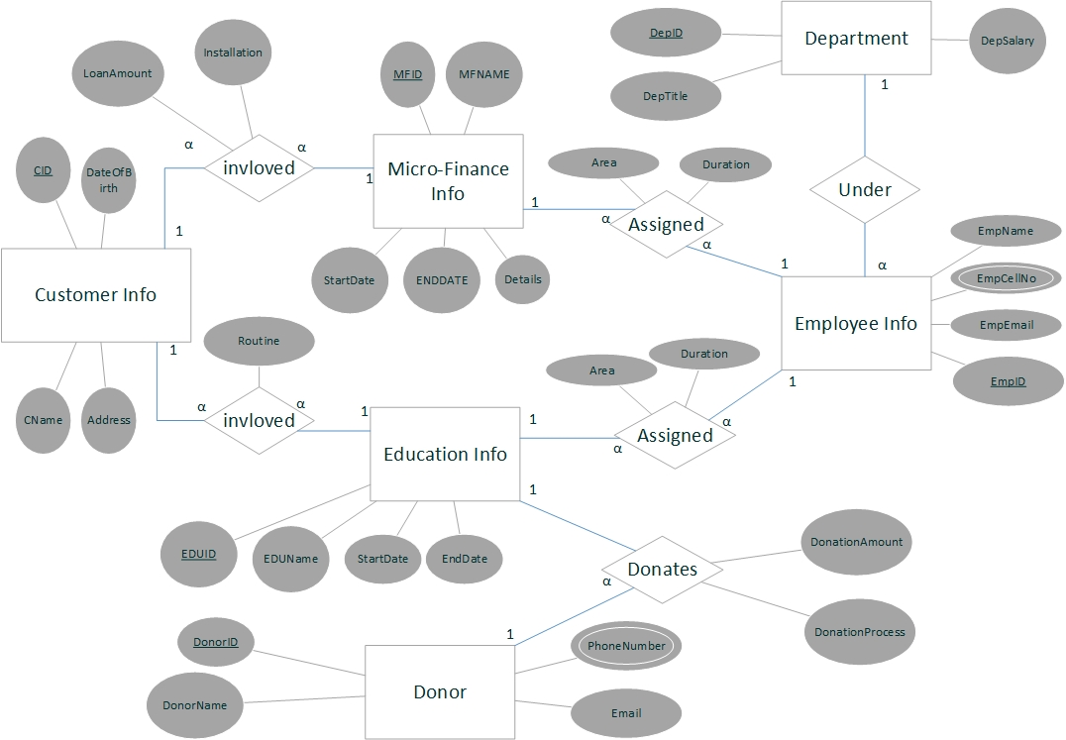

**Database Tables, Attributes & Data Type:**

|  |  |  |
| --- | --- | --- |
| Table Name | Attribute | Data Type |
| MicroFinance_Info | **MFID** | **INT (Primary Key)** |
| MFName | Varchar(100) |
| StartDate | Date |
| EndDate | Date |
| Details | Varchar(1000) |
| Education_Info | **EDUID** | **INT (Primary Key)** |
| EDUNAME | Varchar(100) |
| StartDate | Date |
| EndDate | Date |
| Customer_Info | **CID** | **INT (Primary Key)** |
| CName | VarChar(100) |
| DateOfBirth | Date |
| Address | VarChar(1000) |
| Donor_Info | **DonorID** | **INT (Primary Key)** |
| DonorName | Varchar(100) |
| PhoneNumber (Multivalued) | Varchar(100) |
| Email | Varchar(100) |
| Department | **DeptID** | **INT (Primary Key)** |
| DeptTitle | Varchar(100) |
| DeptSalary | Float |
| Table Name | **Attribute** | **Data Type** |
| Employee_Info | **EmpID** | **INT (Primary Key)** |
| EmpName | Varchar(100) |
| EmpCellNo (Composite Value) | Varchar(100) |
| EmpMail | Varchar(100) |
| Donation | *DonorID* | *INT (Foreign Key)* |
| *EDUID* | *INT (Foreign Key)* |
| DonationAmount | Float |
| Donation Process | Varchar(100) |
| **DonorID, EDUID** | **(Primary Key)** |
| CustomerUnder  Education | *CID* | *INT (Foreign Key)* |
| *EDUID* | *INT (Foreign Key)* |
| Routine | Varchar(70) |
| **CID,EDUID** | **(Primary Key)** |
| CustomerUnder  MicroFinace | *CID* | *INT (Foreign Key)* |
| *MFID* | *INT (Foreign Key)* |
| LoanAmount | Float |
| Installation | Float |
| **CID,MFID** | **(Primary Key)** |
| EducationAssigned  Employee | *EDUID* | *INT (Foreign Key)* |
| *EmpID* | *INT (Foreign Key)* |
| Area | Varchar(100) |
| Duration | Varchar (10) |
| **EDUID, EmpID** | **(Primary Key)** |
| Table Name | Attribute | *Data Type* |
| MicroFinanceAssigned  Employee | *CFID* | *INT (Foreign Key)* |
| *EmpID* | *INT (Foreign Key)* |
| Area | Varchar(100) |
| Duration | Varchar (10) |
| **CFID, EmpID** | **(Primary Key)** |

**Class Diagram:**

* The class diagram is a static diagram.
* It represents the static view of an application.
* Class diagram is not only used for visualizing, describing and documenting different aspects of a system but also for constructing executable code of the software application
* Analysis and design of the object oriented design of an application.
* Describe responsibilities of a system.
* Base for component and deployment diagrams.
* Forward and reverse engineering.

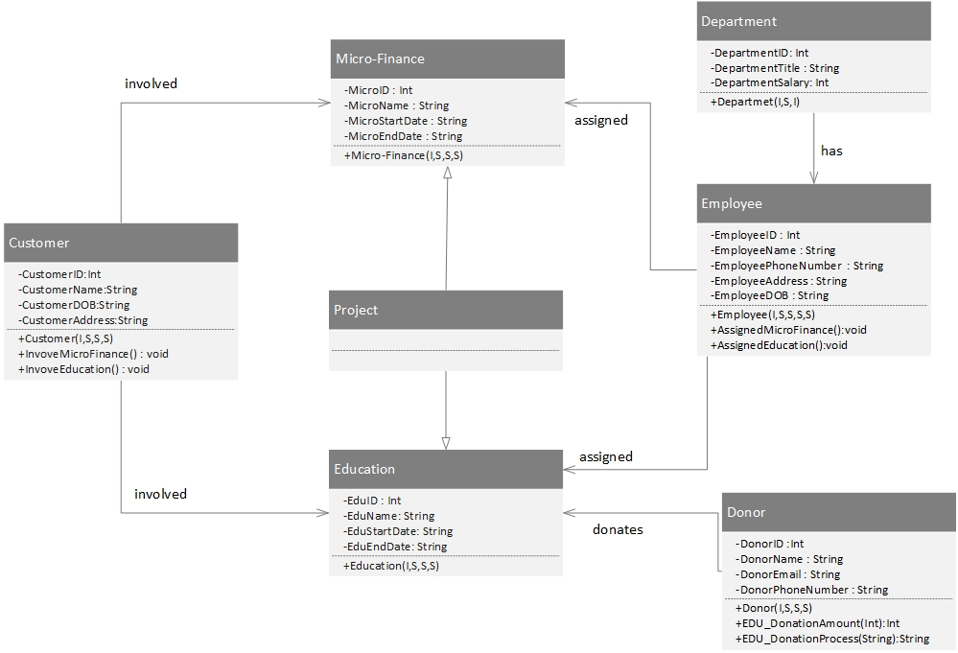

**Conclusion:**

This concludes the ERD and Class Diagram. This report deals with how data are being stored and how they are stored. This also helps to create clear view of usage of this software for different classes when they are proposed and used.